
Weaselhead Grade 7 & 9

Field Trip Teachers Guide Package

Invasive Plant Program
website: theweaselhead.com
email: education@theweaselhead.com

Thank you for your participation in our Grade 7 & 9 Weaselhead Education Program!

The following items have been enclosed in this Teacher’s Guide package:
- Curriculum Connections
- Program Objectives
- Participant guidelines
- Behavioural expectations
- A map of the Weaselhead
- Field trip program outline
- Background information on the Weaselhead Area
- In-class follow up activities

Curriculum Connections:
Grade 7: Unit A – Interactions & Ecosystems
- Investigate and describe the relationships between humans and their environments, and identify related issues and scientific questions.
- Monitor a local environment, and assess the impacts of environmental factors on the growth, health and reproduction of organisms in that environment
- Describe the relationships among knowledge, decisions and actions in maintaining life-supporting environments
Grade 9: Unit A - Biological Diversity
- Investigate and interpret diversity among species and within species, and describe how diversity contributes to species survival
- Investigate the nature of reproductive processes and their role in transmitting species characteristics.
- Identify impacts of human action on species survival and variation within species, and analyze related issues for personal and public decision making.

Program Objectives:
- Identify invasive plant species and understand their impact on ecosystems: Students will learn what invasive plants are and how they disrupt native ecosystems by outcompeting native species for resources.
- Understand plant adaptations and how invasive species outcompete native plants: Students will explore the specific adaptations of invasive plants that allow them to thrive in new environments and dominate native species.
- Apply methods of environmental monitoring to assess ecosystem health and track invasive plant impacts: Students will use environmental monitoring techniques to observe and record the condition of local ecosystems and assess the success of invasive plant removal.
- Analyze the impact of invasive plants on biodiversity, species distribution, and ecosystem health: Students will evaluate how invasive plants reduce biodiversity, alter species distribution, and impact ecological processes like succession
- Understand how human activities contribute to the spread and management of invasive species: Students will examine the role of human actions in the spread of invasive plants, explore methods to prevent further invasions, and consider cultural factors related to the introduction of invasive species.

Before the Trip

Pre-trip preparation
- Please have students divided into 4 or 5 groups per class prior to the field trip
- Students should bring a journal or set-up a field trip journal on a clipboard with blank paper

Participants should
- Wear long pants and dress for the weather. Dress in layers
- Wear closed-toed footwear. This is a safety requirement. Any students not wearing closed-toed footwear will not be able to participate in all activities
- Bring a snack, lunch, and plenty of water for a full day field trip
- Bring pencils or pens
- Bring a Field journal OR blank paper on a clipboard
- Optional: Bring a plastic bag OR mat if the student does not want to sit on the ground

NOTE: This entire program is held outside with no indoor facilities. Students must be prepared for all weather and conditions. They will be hiking approximately 3-5 km on dirt trails and using shovels to remove plants. Appropriate footwear is a safety requirement.

Behavioural expectations:
- Remain in the assigned group and keep in sight of supervisors at all times
- There is always an adult leader at the front of the group and at the end of the group
- NEVER remove natural items from the area. Vegetation, insects, mammals, birds, and amphibian life is to be respected and left in the natural habitat
- Leave no trace of our visit. All litter must be brought back out
- Unsafe behaviour such as tripping, wrestling, fighting, and teasing is unacceptable and may result in withdrawal from the activity
- Cooperation by listening, participating in group discussions, observing and recording is expected during the learning experience
- Each adult is expected to participate in the activities and to provide due safety and care for each of the students
- No headphones or earbuds are allowed. This is for the safety of the participants.

Map of the Area
Your group will be starting their hike at the 37th Street Parking Lot. We will do a hike into the Weaselhead either to the grasslands or down the hill to the bridge. We will also be using the fields and the Aspen Forest in North Glenmore Park.

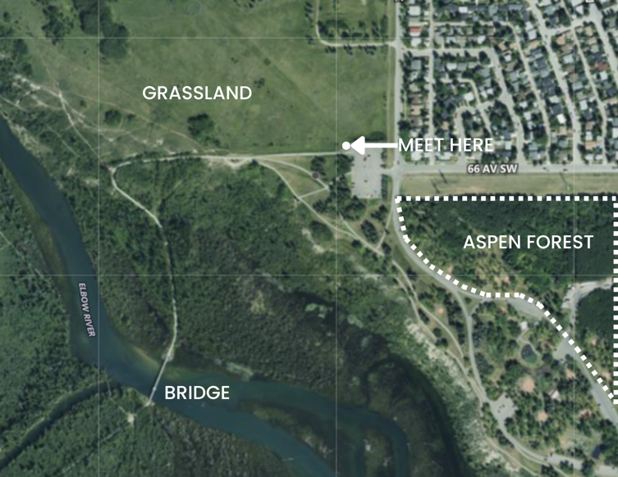

Field Trip Program Outline: FULL DAY

9:30am | - Meet your Naturalists at the grey shed in the NW corner of the parking lot at 37th Street.
9:30 – 9:45am | - Introduction, Land Acknowledgement, park rules, and expectations  - Washroom visit
9:45 – 10:30am | - Learning about invasive plants  - Characteristics and Adaptations  - Impacts  - Control of Invasive Species  - Activity: Invasive Plant matching game.  - Activity: Field Guide practice game.
10:30 – 10:40am | - Snack break
10:40am – 11:40pm | - Botany walk  - Activity: Plant Scavenger Hunt
11:40 – 12:10pm | - Lunch
12:10 – 12:50pm | - Plant mapping  - Activity: Density Game  - Activity: Transects and Quadrats
12:50 – 2:15pm | - Walk to Aspen Stand  - Activity: Invasive Plant removal in the Aspen Forest  - Activity: Invasive Plant Manager Game
2:15 – 2:30pm | - Walk back to parking lot  - Wrap up
Please note: this outline is adjusted by each Naturalist leader to accommodate distances between the classes. If there are 2 or 3 classes coming, we will be visiting different places at different times and may not see each other during the day. The above is just an example of a typical outline.Weaselhead History

Weaselhead History
The Weaselhead area has a name shrouded in mystery, likely connected to the T’suu Tina First Nations, though it has nothing to do with actual weasels! Early settler Sam Livingston, whose house is now part of Calgary’s Heritage Park, was the first European to settle in the Elbow River valley, now known as the Weaselhead.

Today, this protected area spans 404 hectares (989 acres) and is bursting with diverse habitats. Wander through dense White Spruce forests, leafy Balsam Poplar groves, and colorful wildflower meadows. The Elbow River winds through it all, with floodplains, beaver ponds, and wetlands teeming with life.

As you explore, you’ll uncover clues to the area’s rich history. Fossils in sandstone cliffs date back 35 million years, and traces of ancient river paths still shape the landscape. You can find evidence of Indigenous campsites and buffalo hunts, as well as remnants of a military training base that once operated here.

With over 480 plant species, including rare ones like the Western Wood Lily, the Weaselhead is a wildlife haven. Frogs, salamanders, and more than 200 bird species thrive here, while larger animals like moose, bears, and even cougars visit throughout the year.

The Weaselhead is a living tapestry of Calgary's natural and cultural history, offering a rich, engaging experience for all who visit.

REMEMBER: This is a natural area park. It is illegal to remove anything from the area. Fossils and certain plant species are protected in Alberta.

In class Activities

To help students understand and summarize the information they learned during the field trip we have created 2 in-class activities that you can do with your class.

- WANTED POSTER: Have your students create a “Wanted Poster” for an invasive species. This could be for a species they saw during the trip or one they want to learn more about. You can have them do further research on their invasive species using the resources listed below:
  - Resources:
    - Alberta Invasive Species Council: https://abinvasives.ca/
    - Invasive Species Center: https://www.invasivespeciescentre.ca/invasive-species/meet-the-species/invasive-plants/
    - Nature Conservancy Canada: https://www.natureconservancy.ca/en/what-we-do/resource-centre/conservation-101/invasive-alien-species-101.html
    - Minnesota Wildflowers: https://www.minnesotawildflowers.info/
- DESIGN YOUR OWN INVASIVE SPECIES:
  - Go over plant adaptations, for example:
    - Plants growing leaves earlier to have longer to photosynthesize
    - Plants with sticky seeds to help them “travel” through an area
    - Plants that can spread via rhizomes not just seeds
    - Plants with tough roots that can grow through hard packed earth
    - Has thorns to make it hard to eat
  - Working in small groups have students decide on plant characteristics by answering the following questions:
    - Where does it live (habitat)?
    - How does it compete with other plants?
    - How does it protect itself from being eaten?
    - How does it reproduce?
    - How many seeds does it produce?
    - How long are the seeds viable?
    - How does it spread its seeds? (seed dispersal)
  - On the worksheet below have them sketch out their plant OR using craft / art supplies have the students build a dried “sample” of their plant. Botanists frequently dried plants like this. A collection of these dried plants is called an Herbarium.
  - As an alternative instead of having students create their own invasive species you can also have students collect samples of invasive plants in the neighbourhood. They can then identify it and dry the sample to create a class Herbarium!

